$400 Hong Kong Dollar Ingredients

- Quick Cook Oat Meal 1kg
- Brought From Best Mart 360 ~ $18
- Total Price: $18

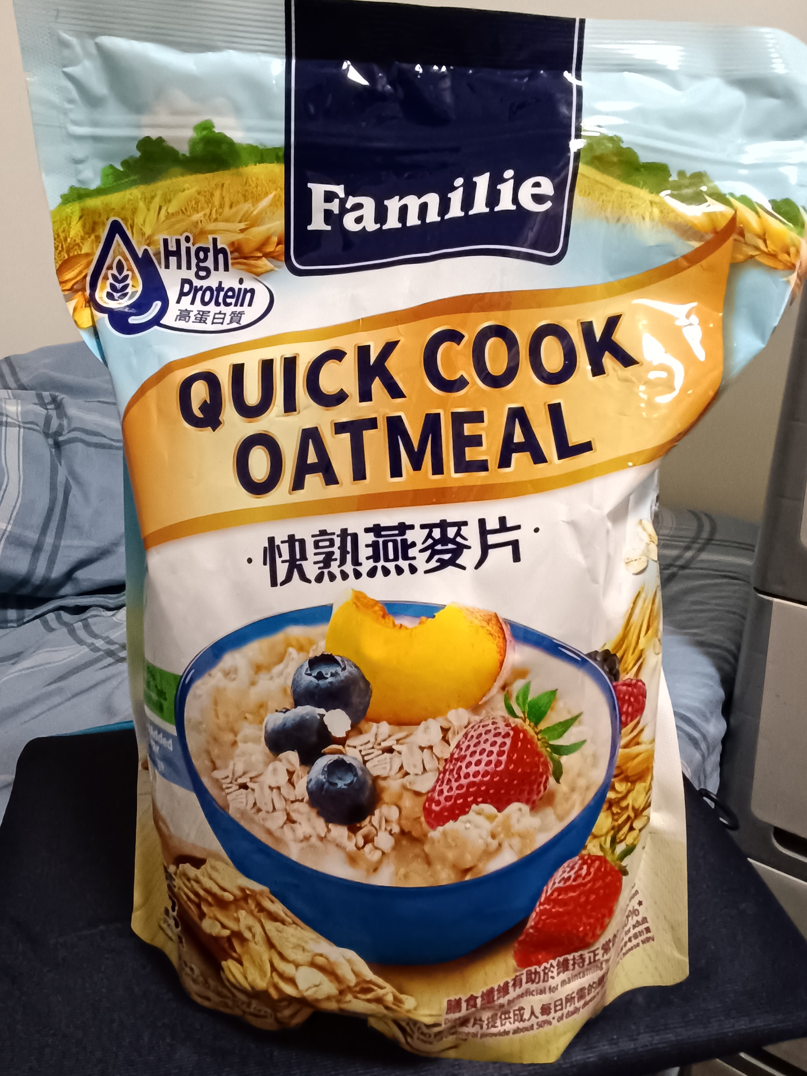

- Chicken Chops X 13
- Brought From Market ~ $11
- Total Price: $143

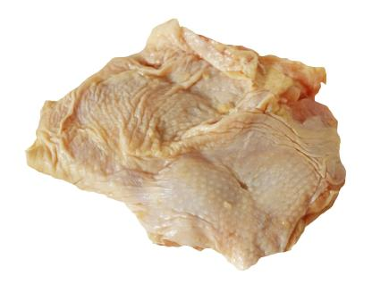
- Rice 5kg
- Brought From Best Mart 360 ~ $49 (Member Price)
- Total Price: $49

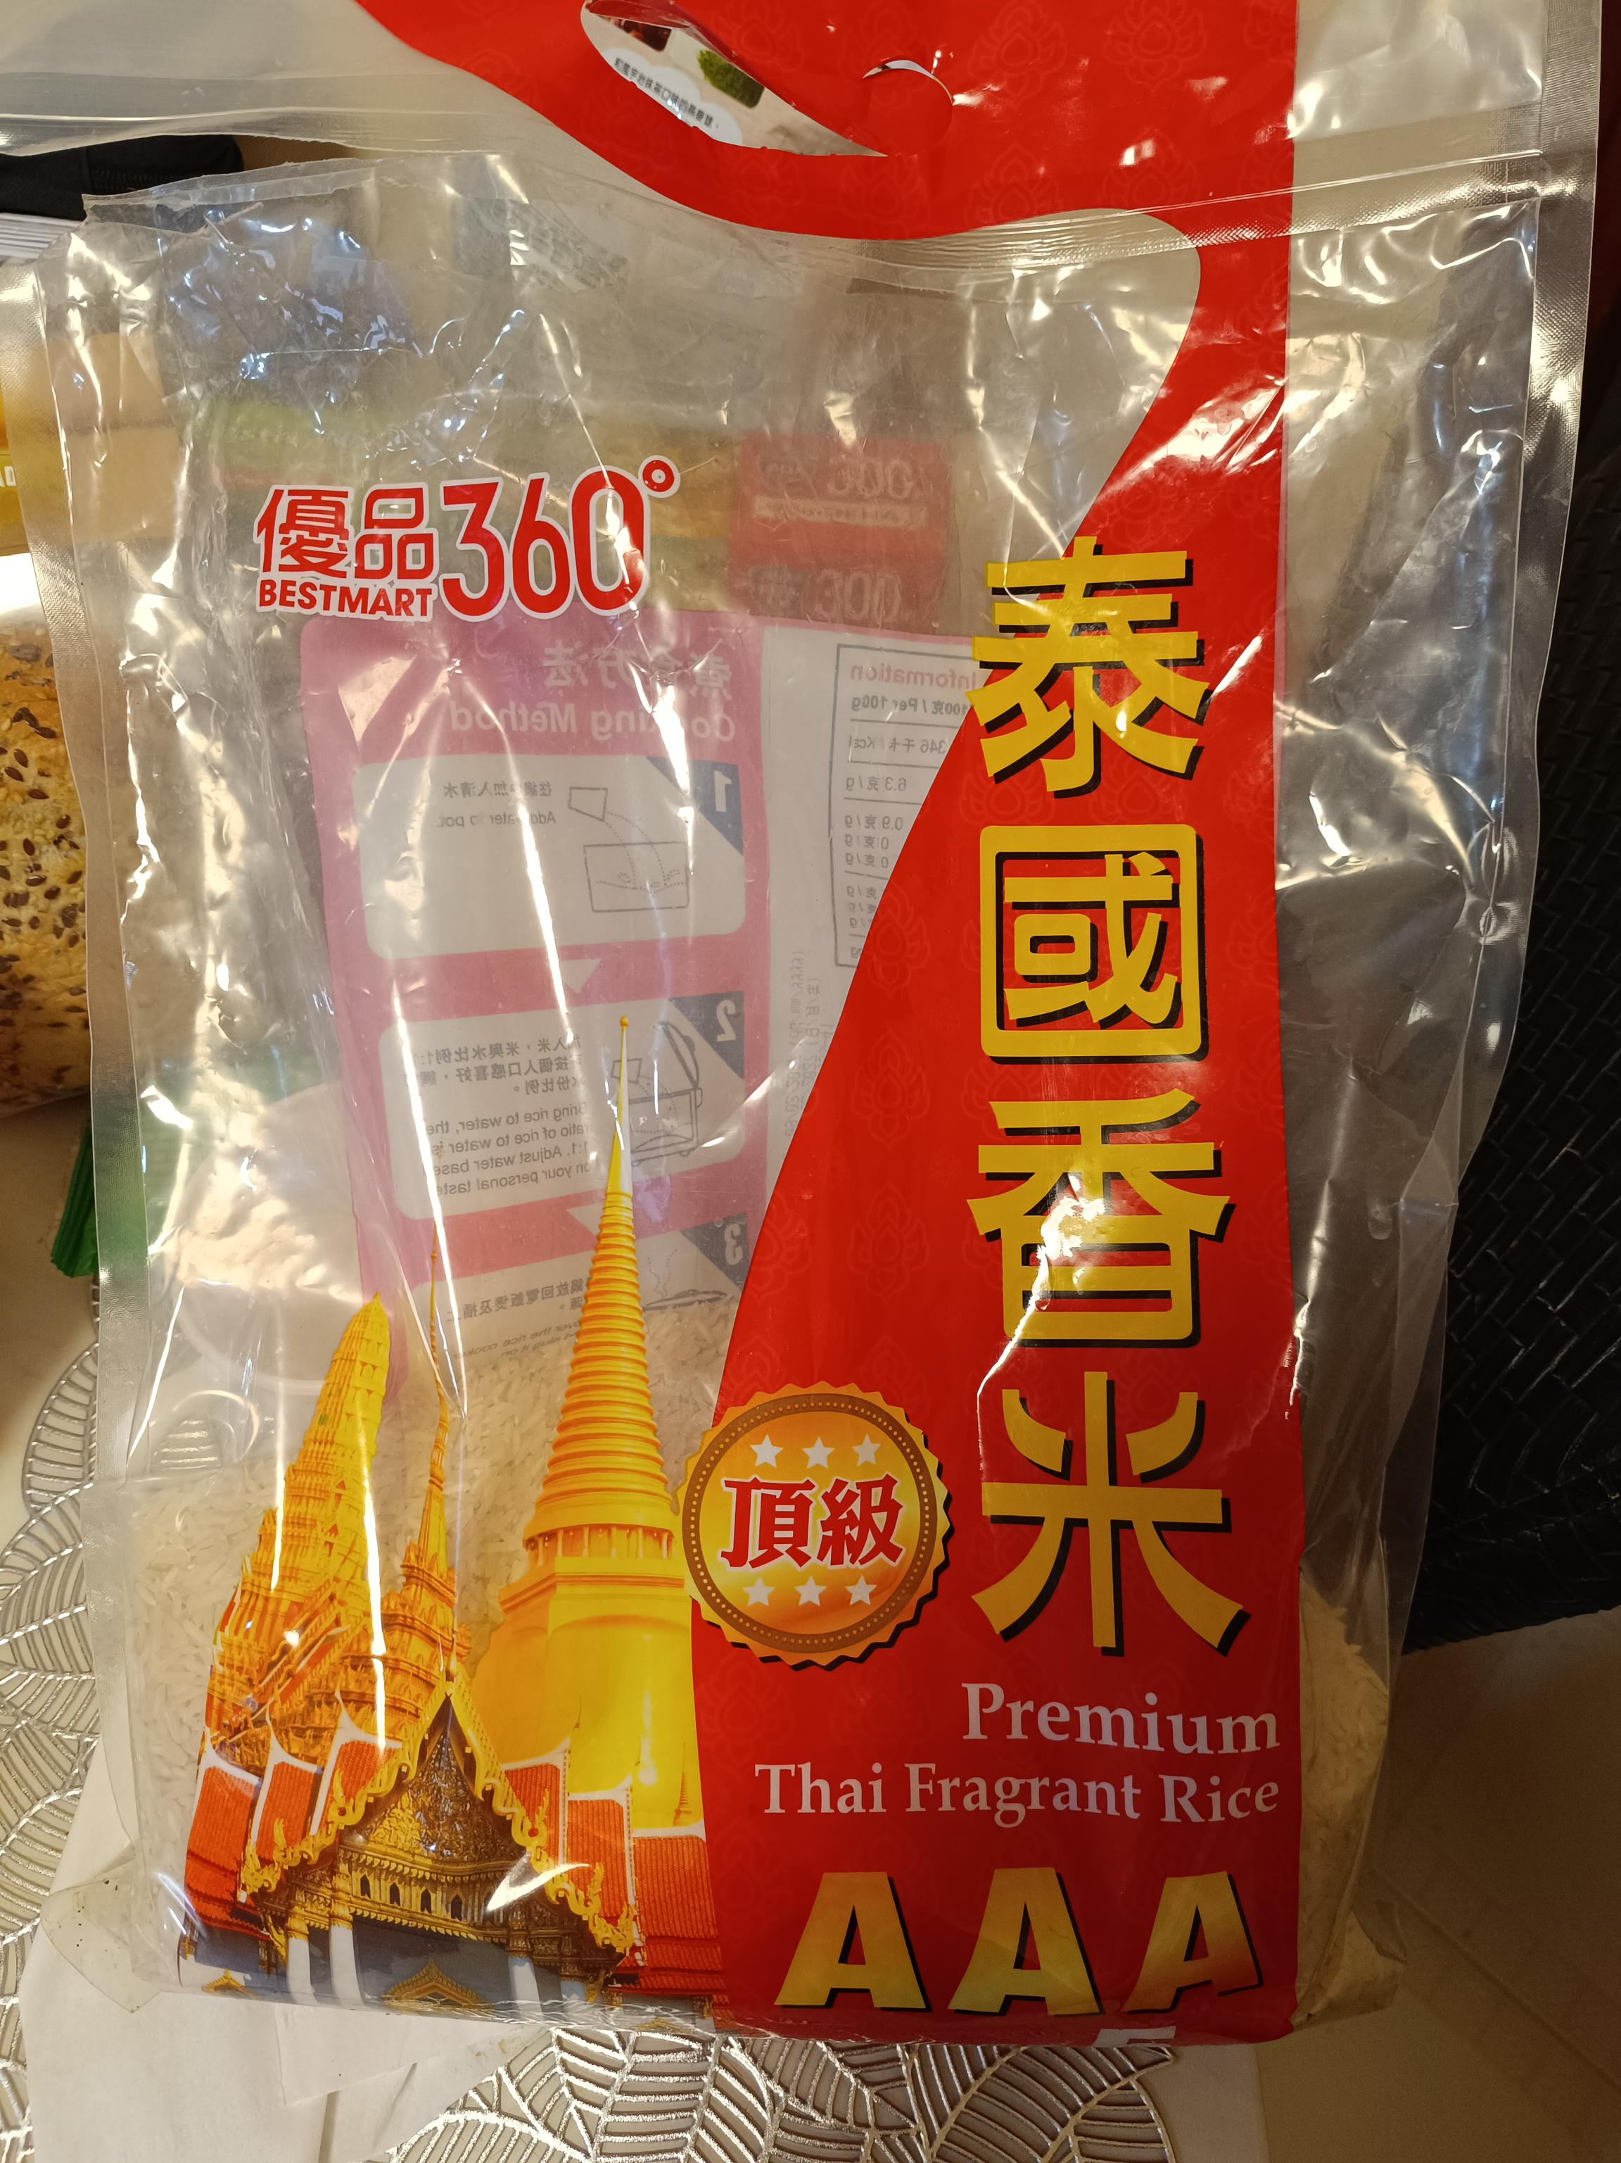

- Vegetables (any vegetables) 5kg
- Brought From Market ~ 1kg ~ $12
- Total Price: $60

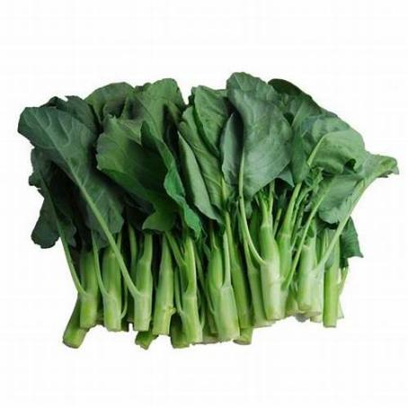

- Meadows瑪利餅 350GM X 3
- Brought From Welcome Supermarket ~ 1 packet ~ $22
- Total Price: $66

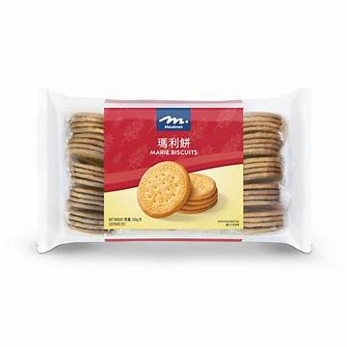

- Devondale Skimmed Milk X 7
- Brought From ParknShop Supermarket ~ $17.9 For 2 / $19.9 For 1
- Total Price: $73.6

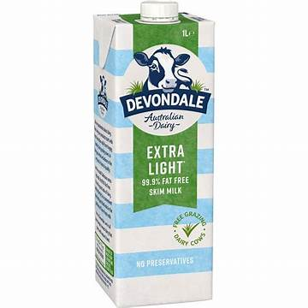

Total Price: $409.6 (Last Updated: 16th May 2025)

Meals - 3 meals Plus Snacks
(Breakfast, Lunch, Dinner, Snacks)

- Breakfast Oat Meal
  - Oat 8 tea spoon (equivalent to 40 gram)
  - either salt / sugar / Soy sauces
  - Water (500ml)

- Morning Snacks
  - Marie Biscult 1 packet

- Lunch
  - Meat Raw ~ 81 gram
  - Vegetable ~ 83.33 gram
  - Rice ~ 125 gram
    - Add water to the pot
    - Add meat (Marinated with salt) and vegetable when the water is fully boiled.
    - Wash the rice and steam the rice.
    - Served.

- Afternoon Snacks
  - Marie Biscult 1 packet

- Dinner
  - Meat Raw ~ 81 gram
  - Vegetable ~ 83.33 gram
  - Rice ~ 125 gram
    - Add water to the pot
    - Add meat (Marinated with salt) and vegetable when the water is fully boiled.
    - Wash the rice and steam the rice.
    - Served.

- Before Bed
  - One cup of skimmed milk (approximate 233 ml)

